# **Name: Abdurrahman Qureshi**

# **Roll No: 210451**

Practical No: 13

1. Write a Program to store, modify and delete a cookie

PHP CODE:

<?php  
$cookie_name = "ek_banda";  
$cookie_value = "Baburao Ganpatrao";  
setcookie($cookie_name, $cookie_value, time() + (86400 * 30), "/");  
  
if (!isset($_COOKIE[$cookie_name])) {  
 echo "Cookie named '" . $cookie_name . "' is not set!";  
} else {  
 echo "Cookie '" . $cookie_name . "' is set!<br>";  
 echo "Value is: " . $_COOKIE[$cookie_name] . "<br>";  
  
 $new_cookie_value = "Manav";  
 setcookie($cookie_name, $new_cookie_value, time() + (86400 * 30), "/");  
  
 echo "Modified Value is: " . $_COOKIE[$cookie_name] . "<br>";  
  
 setcookie($cookie_name, "", time() - 3600, "/");  
 echo "Cookie '" . $cookie_name . "' is deleted!";  
}  
?>

OUTPUT:

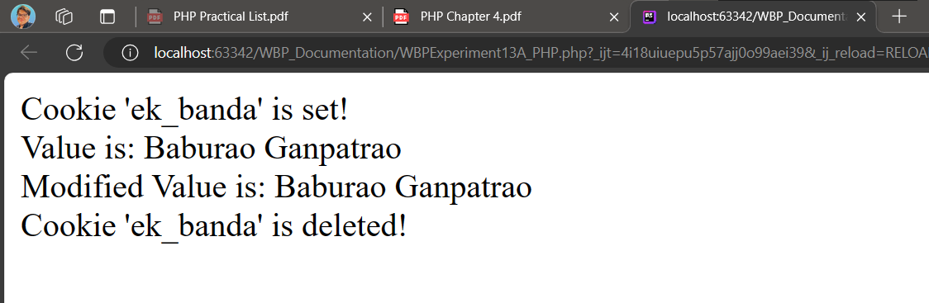

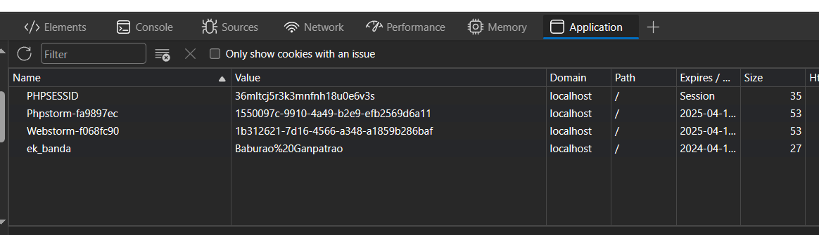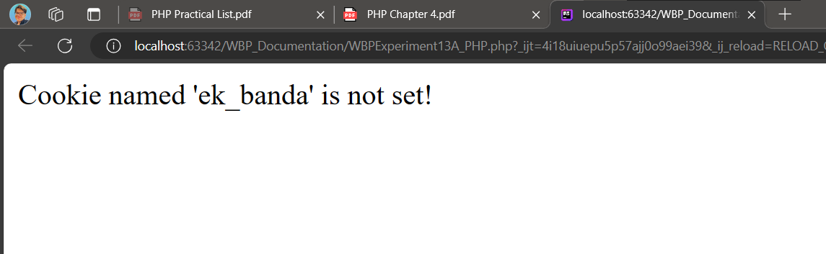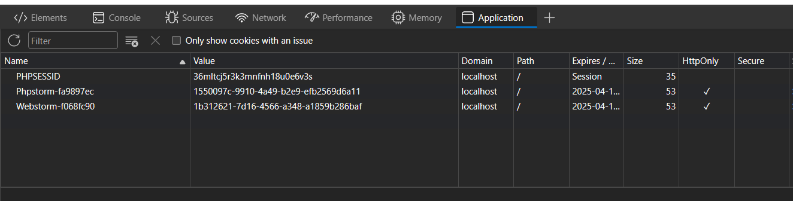

1. Create a registration page and accept the details from user and store them in session variable. Display all details on next page

PHP CODE:

<?php  
  
session_start();  
  
if (isset($_POST['username']) && isset($_POST['email']) && isset($_POST['password'])) {  
 $_SESSION['username'] = $_POST['username'];  
 $_SESSION['password'] = $_POST['password'];  
 $_SESSION['email'] = $_POST['email'];  
  
 echo $_SESSION['username'] . '<br>';  
 echo $_SESSION['email'] . '<br>';  
 echo $_SESSION['password'];  
}

HTML CODE:

<!DOCTYPE html>  
<html lang="en">  
<head>  
 <meta charset="UTF-8">  
 <meta name="viewport" content="width=device-width, initial-scale=1.0">  
 <title>Registration Form</title>  
 <style>  
 body {  
 font-family: Arial, sans-serif;  
 margin: 0;  
 padding: 0;  
 background-color: #f2f2f2;  
 }  
 .container {  
 max-width: 400px;  
 margin: 50px auto;  
 padding: 20px;  
 background-color: #fff;  
 border-radius: 5px;  
 box-shadow: 0 0 10px rgba(0, 0, 0, 0.1);  
 }  
 h2 {  
 text-align: center;  
 }  
 label {  
 display: block;  
 margin-bottom: 5px;  
 font-weight: bold;  
 }  
 input[type="text"],  
 input[type="email"],  
 input[type="password"] {  
 width: 100%;  
 padding: 10px;  
 margin-bottom: 20px;  
 border: 1px solid #ccc;  
 border-radius: 4px;  
 box-sizing: border-box;  
 }  
 input[type="submit"] {  
 width: 100%;  
 padding: 10px;  
 background-color: #4CAF50;  
 color: white;  
 border: none;  
 border-radius: 4px;  
 cursor: pointer;  
 }  
 input[type="submit"]:hover {  
 background-color: #45a049;  
 }  
 </style>  
</head>  
<body>  
 <div class="container">  
 <h2>Registration Form</h2>  
 <form action="./WBPExperiment13B_PHP.php" method="post">  
 <label for="username">Username:</label>  
 <input type="text" id="username" name="username" required>  
  
 <label for="email">Email:</label>  
 <input type="email" id="email" name="email" required>  
  
 <label for="password">Password:</label>  
 <input type="password" id="password" name="password" required>  
  
 <input type="submit" value="Register">  
 </form>  
 </div>  
</body>  
</html>

OUTPUT:

